DEPARTMENT OF PENNSYLVANIA

VETERANS OF FOREIGN WARS OF THE UNITED STATES
MEMBERSHIP AWARDS PROGRAM

2021-2022

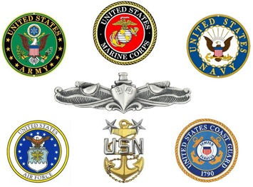

Department Headquarters
4002 Fenton Ave.
Harrisburg, PA 17109-5943
Phone: (717)234-7927 Fax: (717)234-1955
www.vfwpahq.org

Table of Contents

Contents
Message from the Department Commander – Nathaniel Smith 3
Message from the Department Membership Team 3
2020-2021 Membership Programs 4
Individual Membership Rewards 5
Post Level Contests (Post Divisions 1-6) 5
Grass Roots Posts Contests (Post Divisions 7-11) 5
Life Membership to Legacy Life Membership Upgrade 6
Post Membership Awards 6
All-State Post Commanders and Quartermasters Contest 6
All State Post Commanders and Quartermasters Worksheet 7
District Awards 9
Membership Plaques and Awards 11
2021-2022 Department Membership Team 13
2021-2022 Planning Calendar 14
Tools to Boost Membership 16

Message from the Department Commander – Nathaniel Smith

Greetings Comrades.

I know that the last eighteen months has not been so great however we have learned how to adapt and overcome to continue serving Veterans and their families in this great Department. As our immediate past State Commander Peters has stated “Don’t let this pandemic stand in our way to be successful.” As we start a new year and transition of leaders from the Vietnam Era to the Persian Gulf, we need to keep in mind that without membership we cannot prevail, “My motto is “Honor, Courage, Commitment. We need to continue to Honor all Veterans AND have the courage to move this Organization forward. We MUST be 100 % committed to do our due diligence to add new and retain current members into our great organization. I encourage all Post Commanders to reach out to their District Membership Chairperson or ANY State Membership Team member for assistance with scheduling recruiting drives, information sessions, and other events related to Membership.

Focus on these four objectives:

- Recruiting
- Training
- Mentoring
- Retaining
We need to continue to strengthen membership by collaboration with our Auxiliaries, Military Organizations, Employers, and the Community providing facts about the VFW. I believe that ALL posts need to promote the “adopt a unit program” as this program ensures that Veterans know that “Nobody does more for Veterans than the Veterans of Foreign Wars”. We are one team that works together on a mission to continue to put this Department on top where it needs to be. “FULL SPEED AHEAD”

Message from the Department Membership Team
Welcome to the new 2021-2022 VFW program year. This year, your State Membership Team is comprised of highly motivated and deeply passionate committee members that take the concept of membership very seriously. Comrades, simply put, membership is THE MOST IMPORTANT and HIGHLY CRITICAL function we do in the Veterans of Foreign Wars! Our primary mission “to foster camaraderie among United States veterans of overseas conflicts”; to “serve our veterans, the military and our communities”; and to “advocate on behalf of all veterans” cannot be accomplished WITHOUT human capital resources. The very lifeblood and longevity of this organization depends on us having enough people to do our mission.
We look forward to supporting Commander Smith and you! We intend to help grow our VFW by providing you the tools to grow as an Individual, Post and District. As things slowly return to an order of normalcy, we believe there will be an increase in opportunities to expand Membership events throughout the state. When your District or Post does a Membership Drive, please contact us and we will do all we can to get a chairman or Recruiter there to support your event. We all need to have the Honor to do what is needed, the Courage to do it and the Commitment to see it through! FULL SPEED AHEAD!

2020-2021 Membership Programs
Special Notices and Exceptions

- Membership Divisions for all Posts will be same as National Divisions.
- Membership quota for all Department contests is 100% + 1 unless otherwise noted.
- Continuous, new, reinstated and Life Members will be verified by National Headquarters for all Department Contests.
- All Department Membership Contests end April 30, 2022 unless otherwise stated.
- Individuals, Posts and Districts can only win one time in each contest or category unless otherwise stated. The Department Membership Team will make the final determination of all Department awards.
- All contest checks will become the property of the Post or District unless otherwise stated. All checks will be made out to the Post or District Quartermaster unless otherwise stated.
- All requirements for All State Awards must be met by April 30, 2022.
- All membership transmittals for All State Status to receive a cap at Convention must be recorded at Department Headquarters NO LATER THAN April 30, 2022.
- All membership transmittals for All American Status must reach National Headquarters NO LATER THAN June 30, 2022.
- Posts who are in arrears and receive a monetary award, the arrearage will be deducted from the award.
To encourage thorough reading of this important membership program, Commander Smith has inserted Five special graphics into the booklet. You can earn a special prize by locating these symbols and sending a note to State Adjutant/Quartermaster via U.S. Mail, Fax (717-234-1955) or E-mail quartermaster@vfwpahq.org noting the page and location of the symbol listed below:

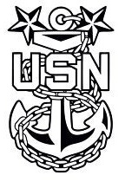

Individual Membership Rewards

Contest No. #1 - Life Membership OTI Attendance Award
Members that attend Officer Training Institute sessions will be eligible for a drawing for 4 life memberships or if already a Life Member, an upgrade to the next tier of Legacy Life membership. If the member is already a Legacy Life Gold member, they will receive a $200.00 Certificate to the VFW Store. Drawing for these memberships will take place at the conclusion of the OTI sessions.

Contest No. #2 – Continuous to Life Membership Monthly Award
A special monthly drawing for two life memberships to be awarded each month and will take place from August 2021 through April 2022. Winners that are continuous members will receive an upgrade to Life Membership.

Contest No. #3 – Life Membership to Legacy Life Monthly Award
Life Members will be entered into a Legacy Life drawing for 2 Legacy Life Memberships each month. If the member is already a Legacy Life Gold, then the winner will receive $200.00 VFW Store Gift Certificate. Contest runs from August 2021 through April 2022.

Post Level Contests (Post Divisions 1-6)

2021-2022 Membership Achievement Awards
All Posts that properly report 100% + 1 in membership, including 15 new/reinstated members, will receive a monetary award and VFW Store gift certificate on dates listed below:

- Contest #4 December 31, 2021 $850 plus a $100 Gift Certificate
- Contest #5 February 28, 2022 $550 plus $100 Gift Certificate
- Contest #6 April 30, 2022 $350 plus $100 Gift Certificate

Grass Roots Posts Contests (Post Divisions 7-11)
Grass Roots Posts that properly report 100% +1 in membership, including 5 new/reinstated members, will receive a monetary award and VFW Store gift certificate on dates listed below:

- Contest #7 December 31, 2021 $850 plus $100 Gift Certificate
- Contest #8 February 28, 2022 $550 plus $100 Gift Certificate
- Contest #9 April 30, 2022 $300 plus $100 Gift Certificate

Life Membership to Legacy Life Membership Upgrade

Post Membership Awards

Contest #10
The Post Commander and Post Quartermaster from each All-State Membership Division with the most new/reinstated members over their membership goal by February 28, 2022, will receive a special award from the State Commander.

All-State Post Commanders and Quartermasters Contest

Contest #11
All-State Post Commanders will receive a distinctive VFW Cap, an All-State Commander's Pin and special recognition at the State Convention.
An outstanding Post Commander will be selected Captain of the All-State Team based on the scoring of the All-State worksheet & membership over their goal by April 30, 2022 will receive a special gift from State Commander Smith at the State Convention.
Contest #12
All-State Quartermasters will receive a distinctive VFW Cap, an All-State Quartermaster's Pin and special recognition at the State Convention.
An outstanding Post Quartermaster will be selected Captain of the All-State Team based on the scoring of the All-State worksheet & membership over their goal by April 30, 2022 and will receive a special gift from State Commander Smith at the State Convention.
ALL-STATE POST DIVISIONS & QUOTA
Division Membership Minimum %
Division 1 951-+ 100% + 1
Division 2 750-950 100% + 1
Division 3 356-749 100% + 1
Division 4 246-355 100% + 1
Division 5 185-245 100% + 1
Division 6 143-184 100% + 1
Division 7 112-142 100% + 1
Division 8 88-111 100% + 1
Division 9 68-87 100% + 1
Division 10 51-67 100% + 1
Division 11 1-50 100% + 1

All State Post Commanders and Quartermasters Worksheet
To be considered for All State Status this worksheet must be submitted to
Department Headquarters, 4002 Fenton Avenue. Harrisburg, PA 17109-5943
Postmarked no later than April 30, 2022 to receive Cap at Convention
ALL STATE WORKSHEET IS MANDATORY

Name__________________________________Post #__________ District # ____________
Mandatory Criteria
- Membership Properly Reported as attaining percentage goal of 100% + 1.
- All Post and Home Association By-Laws (if Applicable) must be Current (within the previous 5 years)
- Post/District must have Articles of Incorporation on file with Department Headquarters.
- Purchase Buddy Poppies. (5 Per Member) Date: ___________ Check # ________
- Voice of Democracy Entry. Yes [ ] No [ ]
- Patriot’s Pen Entry. Yes [ ] No [ ]
- Veterans and Military Support Fund Raiser for donation to VMS Fund, min. $100.00 Date:______
Donations should be made at: https://heroes.vfw.org/page/22950/donate/1
- National Home Donation (Dept. Division 1-6 $100—Dept. Division 7-11 $50.00) (Must be sent to Department Headquarters Earmarked for National Home) Date: ________ Check #: _______
- Donation to Commander’s Special Project (Dept. Division 1-6 $100—Dept. Division 7-10 $50.00). Must be sent to Department Headquarters Earmarked Special Project (PA Wounded Warriors).
Date: ______ Check # _________
- VAVS Donation (Dept. Division 1-6 $100 – Dept. Division 7-11 $50.00) Must be sent to Department Headquarters Earmarked VAVS. Date: ______ Check # _________
- All Post Monthly Community Service Reports for September 2021 – April 2022 must be on file with the department chairman. All Community Service reports must be received by Chairman Mark Webster (NOT DEPARTMENT) by the 15th of the following month.
- Post/District must have submission of one EMT OR Firefighter OR Police Officer Candidate for Dept. Safety Award (Entries must be received in Dept. Headquarters by December 31, 2021)
- All Post / District Quarterly Trustee Audits Including June 2021 must be on file.
Dates Trustee Reports sent to Dept. June: ______ September ______ December______ March ___
- Post / District must have QM Bonded and on record at Department HQ. Date: ______ Check # ______
- Post/District Commander and/or Sr. Vice Commander and/or Jr. Vice Commander and/or Quartermaster must attend all District Meetings (Post/District CMDR must attend at least attend 50% of ALL District Meetings).
- Post/District must have a registered Service Officer (Current Fee Paid).
- Post/District must not be in arrears for the current or prior year (e.g., dues, audits, election reports, etc.)
- Post Inspection is recorded for 2021-2022. Date Inspected_________ By _____________________
- All-State requirements must be completed July 1, 2021, to April 30, 2022, to receive cap at Convention.

To be considered for All State Status the worksheet must be submitted to
Department Headquarters, 4002 Fenton Avenue. Harrisburg, PA 17109-5943
Postmarked no later than April 30, 2022
ALL STATE WORKSHEET IS MANDATORY
The score will be calculated at Department Headquarters. The points will be used to determine the All-State Captains. Records must be on file at Department Headquarters to Qualify.

POINTED CRITERIA: _____________________________________________POINTS:________

Purchase 10 Buddy Poppies per member 10 _____
Membership % goal by Dec. 31, 2021 20 _____
Or Membership % goal by Feb. 28, 2022 15 _____
Or Membership % goal by Apr. 30, 2022 10 _____
New or Reinstated Member by Dec. 31, 2021 Maximum 75 pts 5 ea _____ Community Activity Record Book Submitted for Judging 30 _____
Americanism Program 20 _____
Community Activities Participation 20 _____
Safety Program 20 _____
Youth Activities Participation (e.g., Scouts, JROTC, etc.) 10 _____
Participate in the Adopt a Unit Program 10 _____
Participate in Citizenship Education Teacher Award (E.g., Voice of Democracy) 10 _____
Donation to Barger Nursing Scholarship 10 _____
Post/District Officers attend the Dept. Regional School of Instruction (OTI) 10 _____
Post/District Inspection submitted to Department by December 31, 2021 10 _____
Donation to Homeless Veterans Program 10 _____
Voice of Democracy Student 30 _____
Patriot’s Pen Student 30 _____
Donation to State Commander’s Special Project: 20 _____
Law Enforcement Candidate 30 _____
Fire Fighter Candidate 30 _____
Emergency Medical Services Candidate 30 _____
Citizenship Teacher of the Year Entry – Smart Maher (K-12) 30 _____
Post/District Commander must Attend at least One Dept. Recruiting Instruction* 60 _____
(*Dept. Membership Chair Validates Attendance - This is not OTI!)

District Awards

2021-2022 District Membership Awards

All Districts that properly report their membership goal of 100% + 1 will receive an award for the District. Dates and awards listed below.

- Contest #13 December 31, 2021 $1200
- Contest #14 April 30, 2022 $700
- Contest #15 June 30, 2022 $500

2021-2022 District Life Membership Achievement Award*

All Districts that properly report 25 new Life Members (includes annual going life) will receive an award for the district.

- Contest #16 December 31, 2021 $500
- Contest #17 April 30, 2022 $300
- Contest #18 June 30, 2022 $200

2021-2022 District Commander Awards

Contest #19

All District Commanders and District Membership Chairperson’s who have attained their membership goal of 100% +1 by April 30, 2022 will receive:
- All State District Commander’s Cap at Convention
- Jacket (Style to be determined by State Commander)
- Special Recognition at the State Convention

Contest #20

All District Commanders and District Membership Chairperson’s who have attained their membership goal of 100% + 1 between May 1, 2022 and June 30, 2022 will receive:
- All State District Commander’s Cap
- Special Recognition at the State Convention

Note: In order to Qualify for this award all, the following must be Completed and Submitted to Department: District Inspections, Post Inspections and Post and District Quarterly Audits.

Contest #21

If we become an All-American Department, all District Commanders, State Membership Team and Certified National Recruiters will receive an incredibly special reward from State Commander Smith –
(To Be Announced)

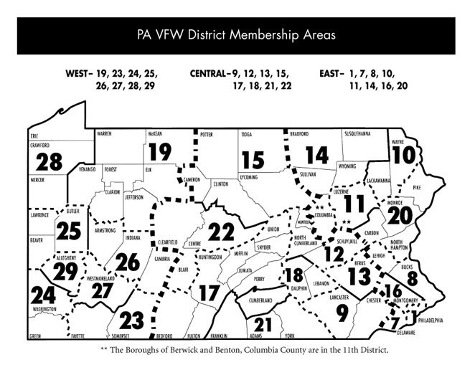

Membership Plaques and Awards

The Joe Salvo Award for Individual Post Members

Contest #22

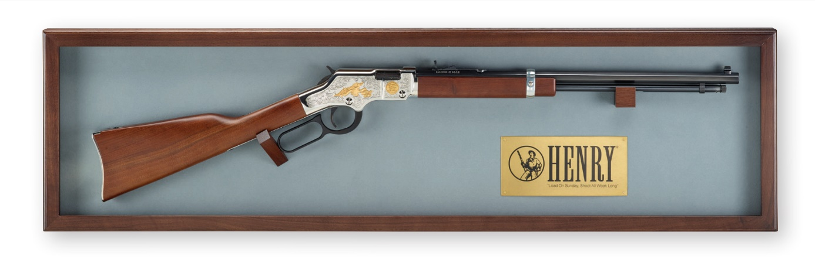
A Henry VFW Tribute Rifle will be presented to the individual member who signs up the most new and reinstated members (over 25 members) between July 1, 2021 and April 30, 2022. This award will be presented at the 2022 Department Convention. The National Recruiter Report will be used to verify the member.

Chosnyk Plaque
Contest #23

This plaque is awarded to the district having the greatest percentage increase as of April 30, 2022.

Post Commander’s Award
Contest #24

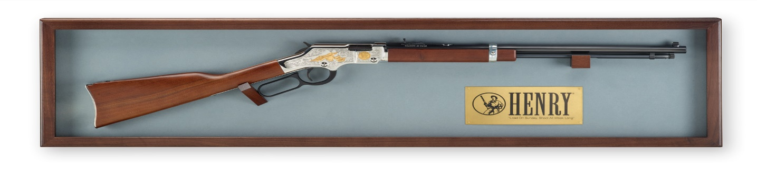
This Henry VFW Post Tribute Rifle will be awarded to the Post with the highest numerical increase as of April 30, 2022.

Robert Musser Memorial Plaque

Contest #25
This plaque will be awarded to the Post having attained the greatest percentage of increase as of April 30, 2022.

Van Zandt Award

Contest #26
To be eligible, a Post must recruit at least 25 new/reinstated members prior to April 30, 2022. The Post recruiting the most new/reinstated members as a percentage of existing membership receives a plaque.

Contest #27
For every Post member or auxiliary member who recruits five (5) new/reinstated auxiliary members will receive a pin from the State commander and be entered into a drawing for $250.00 presented at the State Convention 2021-2022.

Special Note
Districts and Posts must meet their membership goal, inspected, and report participation in Community Service, Patriot’s Pen Essay, Voice of Democracy, Safety, Youth Activities, Buddy Poppy, Citizenship Education in the current Commander’s Membership Year to qualify for plaques and award. The plaques and the Van Zandt Award will be presented at the first general session of the Convention.

.

2021-2022 Department Membership Team
Department Membership Chairman:
John August Otte Post 3258
368 Village Way, Chalfont, PA 18914 District 8
Cell Phone (267) 644-7942 or 267-645-9716 Email: Membership@vfwpahq.org

Department Membership Co-Chairman (Eastern)
VACANT

Department Membership Co-Chairman (Central)
Robert E. Hinkle Jr. Post 5265
6357 Salem Run Rd, Dover, PA 17315 District 21
Cell Phone: (717) 542-6948 Email: Membershipcentral@vfwpahq.org

Department Membership Co-Chairman (Western)
Carl Trusiak Post 566
205 Truxall Rd, Apollo, PA 15613-9005 District 27
Cell Phone: (724)448-4945 Email: Membershipwest@vfwpahq.org

Western Districts Recruiters
Earl “Greg” Stump Post 6391
952 Coleman Mills Road, Port Allegany, PA 16743 District 19
Cell Phone (760) 443-6811 Email: buckskintitan@yahoo.com

Bill Csaszar Post 3945 4239 Stanton Avenue, Pittsburgh, PA 15201 District 29 Cell Phone (412) 592-2172 Email: sfcbillc@gmail.com

Wally Paciorkowski Post 8427
214 Tarragonna Street, Pittsburgh, PA 15210 District 27
412-607-3923 recruitercentrealwest@vfwpahq.org

Life Membership/Gold Legacy Chairman
Gary Smith Post 1446
12621 Gum Tree Rd, Brogue, PA 17309 District 21
Cell (717) 262-357 Email: vfw6241@comcast.net

VFW Certified National Recruiters (CNR)
Dave Gyger Email: djc57@verizon.net
Cecil Dennis Email: cecil_dennis@hotmail.com
Henry Mannella Email: h.mannella72@yahoo.com
John Otte Email: Membership@vfwpahq.org

2021-2022 Planning Calendar
2021

July 4 & 5 Independence Day (Department HQ Closed)

July 8 -11 National Commander-in-Chief’s Homecoming (Portsmouth, VA)

August 13 PA District 21 Golf Scramble, The Bridges Golf Club
6729 York Rd., Abbottstown, PA 17301

August 13 &14 Department Flying Squadron, Sheraton Harrisburg-Hershey Hotel
4650 Lindle Road, Harrisburg, PA 17111 (Invitation Only)

August 15: South Central Officer’s Training, VFW Post 8896
107 E. Locust St. Ext, East Berlin, PA 17316 (717) 259-0124

August 16: North Central Area Officer’s Training, VFW Post 8724 (6:00 PM)
1665 Newry Lane, Duncansville, PA 16635 (814) 695-9703

August 20 & 21 VFW Auxiliary Program & Leadership Conference Red Lion Hotel,
4751 Lindle Road, Harrisburg, PA
August 21 Southeastern Area Officer’s Training VFW Post 9220
1236 Lavender Road, Bensalem, PA 19020 (215) 245-1252
August 22: Northeastern Area Officer’s Training, VFW Post 7251
179 Boulevard Ave, Throop, PA 18512 (570) 489-4021
August 28 Northwestern Area Officer’s Training, VFW Post 2006
1045 S. Morgan St. Meadville, PA 16335 (814) 333-8444
August 29 Southwestern Area Officer’s Training, VFW Post 1810
3801 Clariton Blvd, Pittsburgh, PA 15227 (412) 881-9934
September 6: Labor Day (Department HQ Closed)
September 11: Patriot’s Day
September 17: POW-MIA Day
September 26: Gold Star Mother’s Day
October 11: Columbus Day (Department HQ (Closed)
October 15-17 Women Veterans Retreat – Ramada Conference Center, State College, PA
October 21-23 State Commander’s Testimonial- Breinigsville
Oct 29-31: Eastern States Conference, Ocean City, MD
November 8: Election Day

2021, Cont’d

November 11 & 12 Veterans Day (Department HQ Closed)
November 25 -26 Thanksgiving Holiday (Department HQ Closed)
December 24: Christmas Holiday (Department HQ Closed)
December 25 Christmas Day ( Department HQ Closed)
December 31: New Year’s Eve (Department HQ Closed)

2022

January 1: New Year’s Holiday (Department HQ Closed)
January 17: Martin Luther King Jr (Department HQ Closed)
January 21-22 Mid-Winter Conference: Wyndham Hotel, 2110 Lincoln Hwy East, Lancaster, PA
January 29-Feb 3 VFW Auxiliary Mid-Year Conference & Celebrating Freedom
Melbourne & Cape Canaveral, FL
February 21: President’s Day (Department HQ Closed)
February 26-March 2: Voice of Democracy Celebration: Washington, DC
February 27-March 3: Legislative Conference, Washington, D.C.
March 11-13: Women Veterans Retreat, Harrisburg, PA
April 15-18 Good Friday & Easter Holiday Weekend (Department HQ Closed)
April 1-2: VFW Auxiliary President’s Testimonial: Pittsburgh Marriott North
100 Cranberry Woods Drive, Cranberry Township, PA
May 1: Loyalty Day
May 30: Memorial Day (Department HQ Closed)
June 8-11 State Convention - Wyndham Hotel, 2110 Lincoln Hwy East, Lancaster, PA
June 19 -20 Juneteenth – (Dept HQ Closed)

Tools to Boost Membership
4 Steps for the Post Commander in Planning A Successful Recruiting Campaign
Step #1:
- Select and organize a membership committee.
- Qualities of a successful Membership Chairman:
  - Popular, organized, good speaker, knowledgeable about the VFW, dedicated
- Qualities of a successful Committee member:
  - Active, knowledgeable about the VFW, dependable
Step #2:
- Develop a recruiting plan
- 5 Elements of a recruiting plan that works:
    - Analysis of the current situation (Where you are in terms of members, recruitments, other Posts’ territories members and recruitments. Use last year’s membership as a base for your goals).
    - Goal Setting (Where you want to go)
    - Development of action plans
  - Territory and time management
  - Manpower management and planning
  - Recruiting meetings and techniques
    - Implementation of action plans
  - Translate plans on paper into actions carried out by the recruiting team
    - Tracking results
  - Use a system of controls and measurements to assure results are achieved
Step #3:
- Set realistic goals - Two types of goals in your plan should include: Quotas and Objectives USE THE SMART system for goal setting:

- SPECIFIC - For example, the focus of the plan should not be just to increase recruiting by numbers, but to increase by a certain number through specific recruiting
- MEASURABLE - A definite measure to increase members in your Post by a certain percentage or set number techniques
- ATTAINABLE - Goals should require effort (ambitious), but attainable
- RESULTS ORIENTED - Goals aimed at achieving a specific result
- TIMED - Track your progress throughout the time to ensure you achieve goals at the end of the stated time. Consider setting up recruiting deadlines to coincide with National, Department and District/County awards so members are eligible for awards sponsored by National, Department, District and County.
Step #4:
- Plan your activities.
- The 3 R’s of membership growth:
- Retain Continuous members
- Reinstate former members
- Recruit NEW members

- Five proven recruiting techniques:
- Personal contact - Door-to-Door, membership booths, meetings
- Recruiting booths/tables
- Mail
- Referrals
- Telephone campaign. Note: Personal contact is the most effective way to reach prospective members. Whatever recruiting method you use, always arrange a face-to-face meeting with the prospect.

Periodicals

Offer to make the State and National publications available for the waiting rooms of professional offices—doctors, dentists, lawyers, etc.—in your town. Place a membership application in the publication.

Public Service TV/Radio/Cable Network

Advertise your Post. Tell the people you are going to have a Memorial Day Service, Veterans Day Service, Loyalty Day program or other Post or Auxiliary event that would attract community members. Remember, everyone is welcome. Get the word out through Public Service Announcements mailed for fazed to TV and radio stations. Call News Directors or Editors at your local stations for information about submitting Public Service Announcements.

Post Open House

Have an open house at your Post with your officers and invite all veterans and their families from the surrounding community. Maybe you can sponsor a free buffet or dinner for local troops or military units that are departing to or returning from overseas deployment.

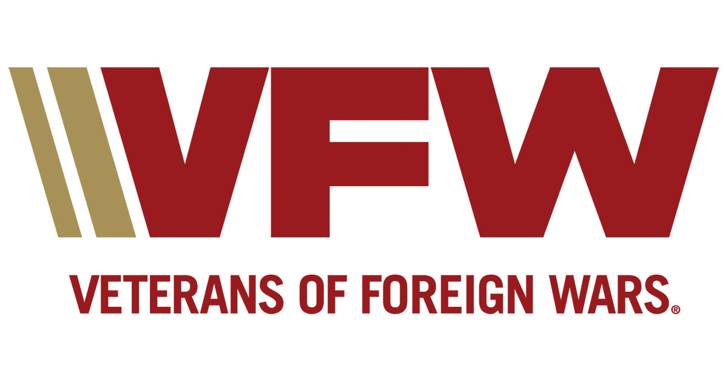
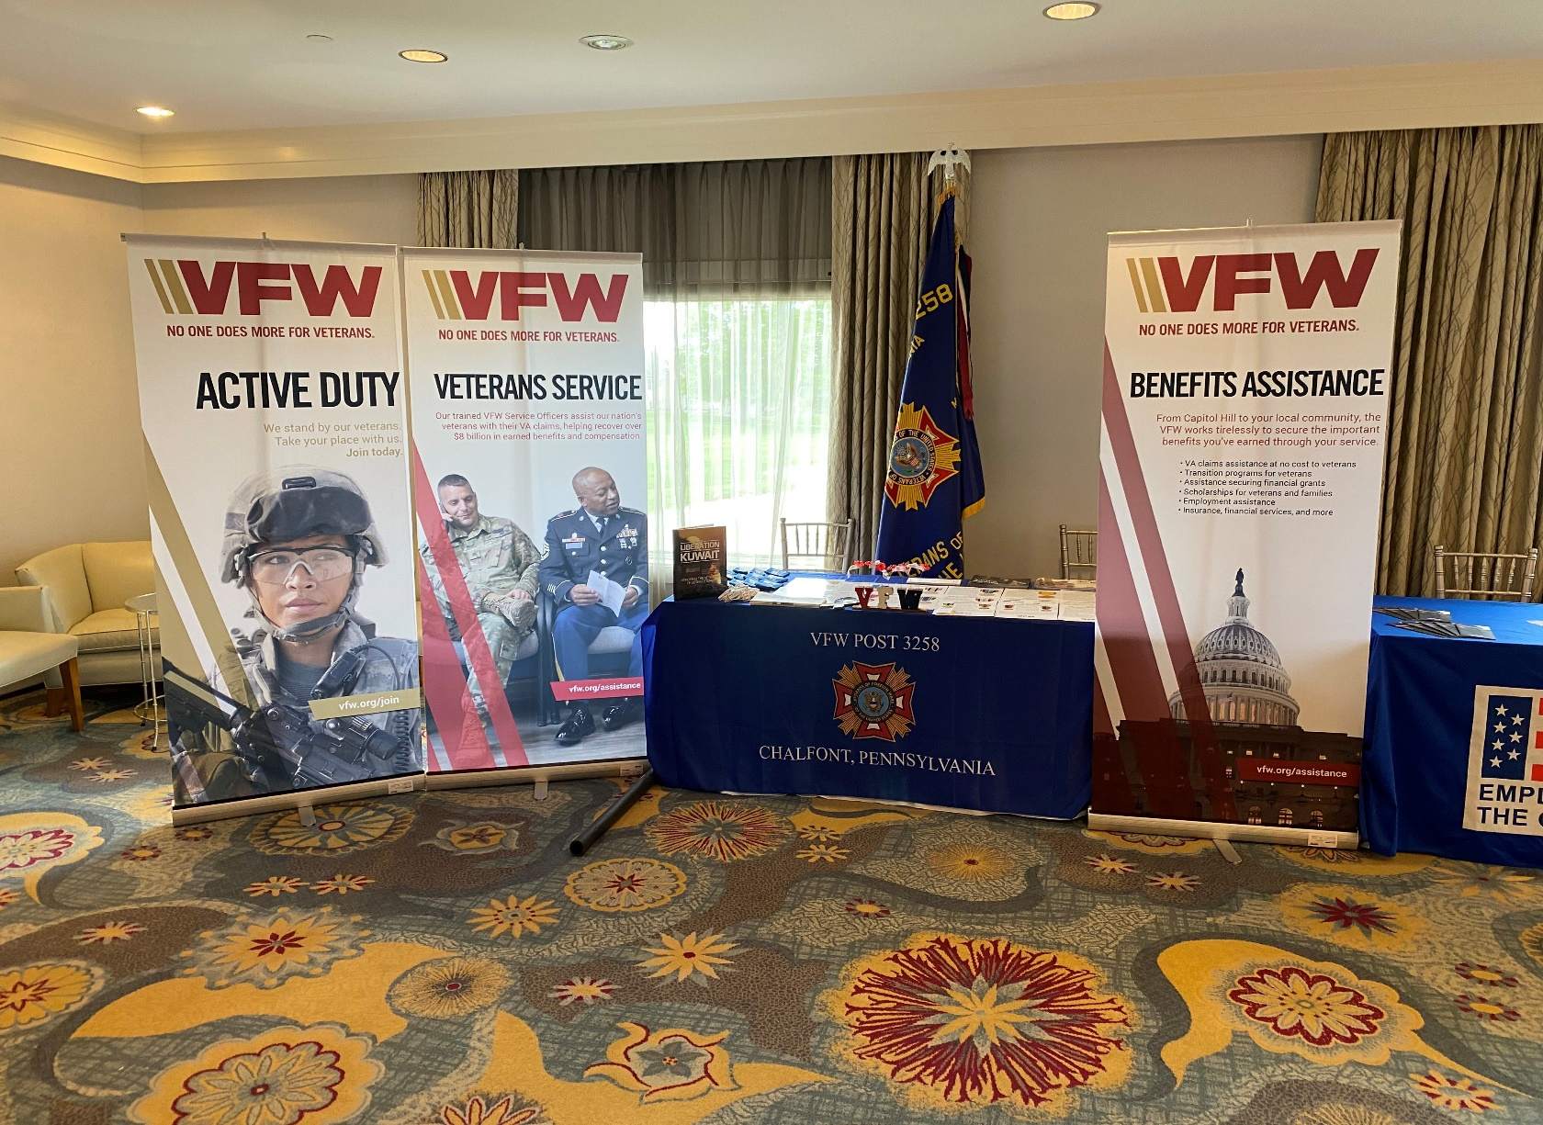

NO ONE DOES MORE FOR VETERANS

